**Spicejet_Project**

**Console_output:**

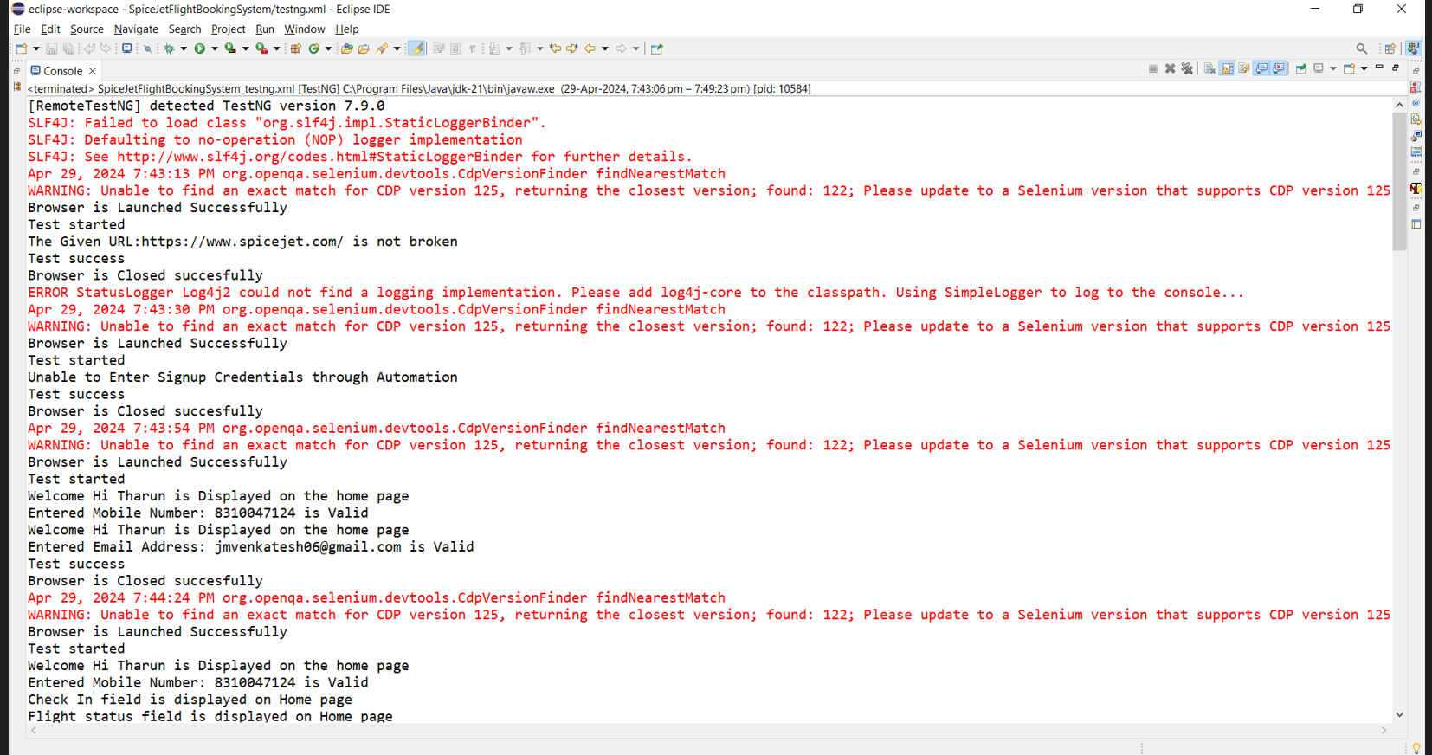

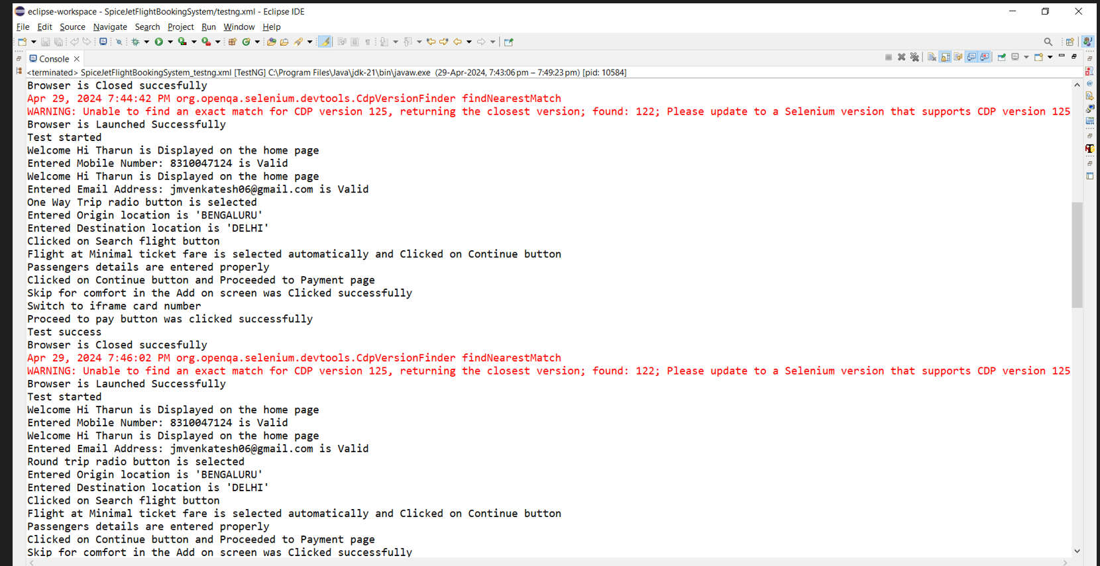

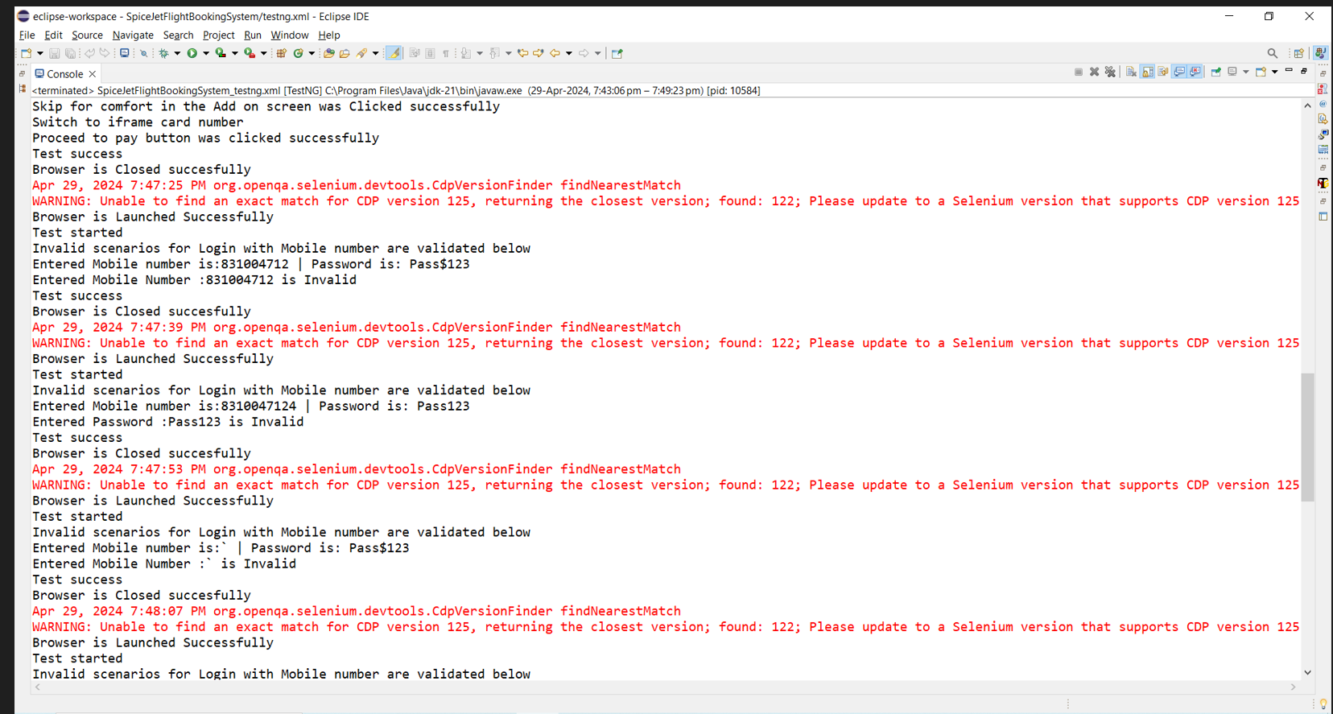

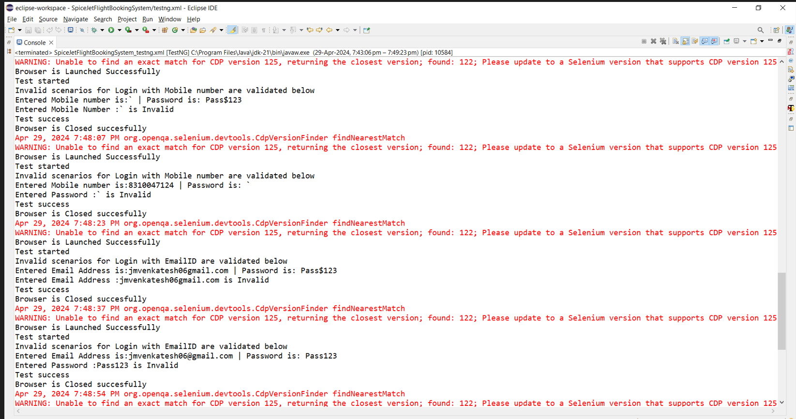

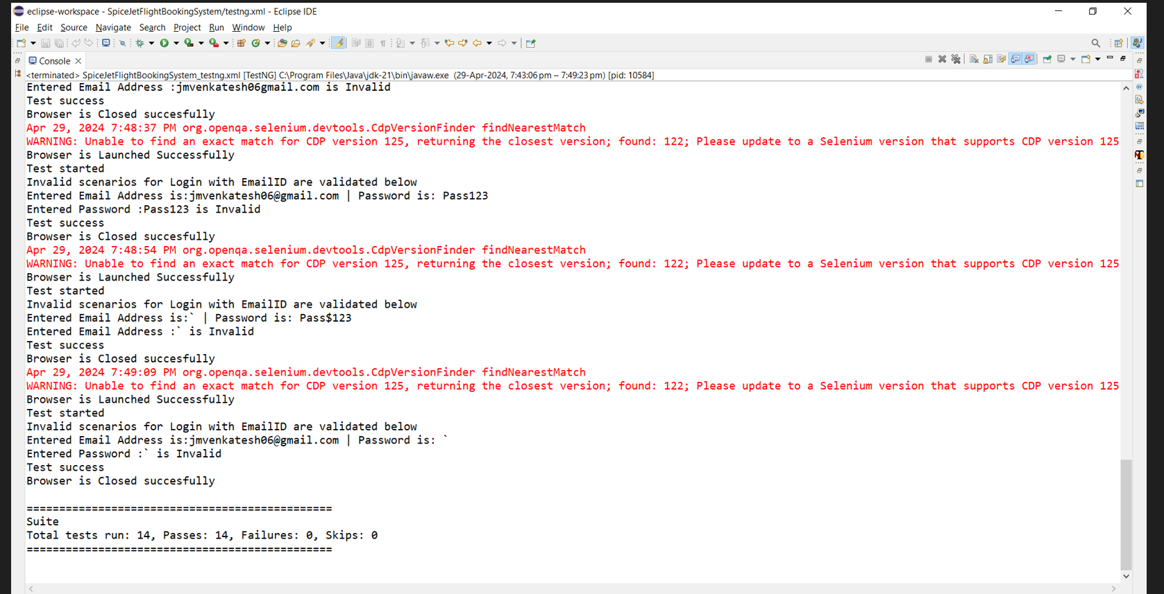

**Maven_output:**

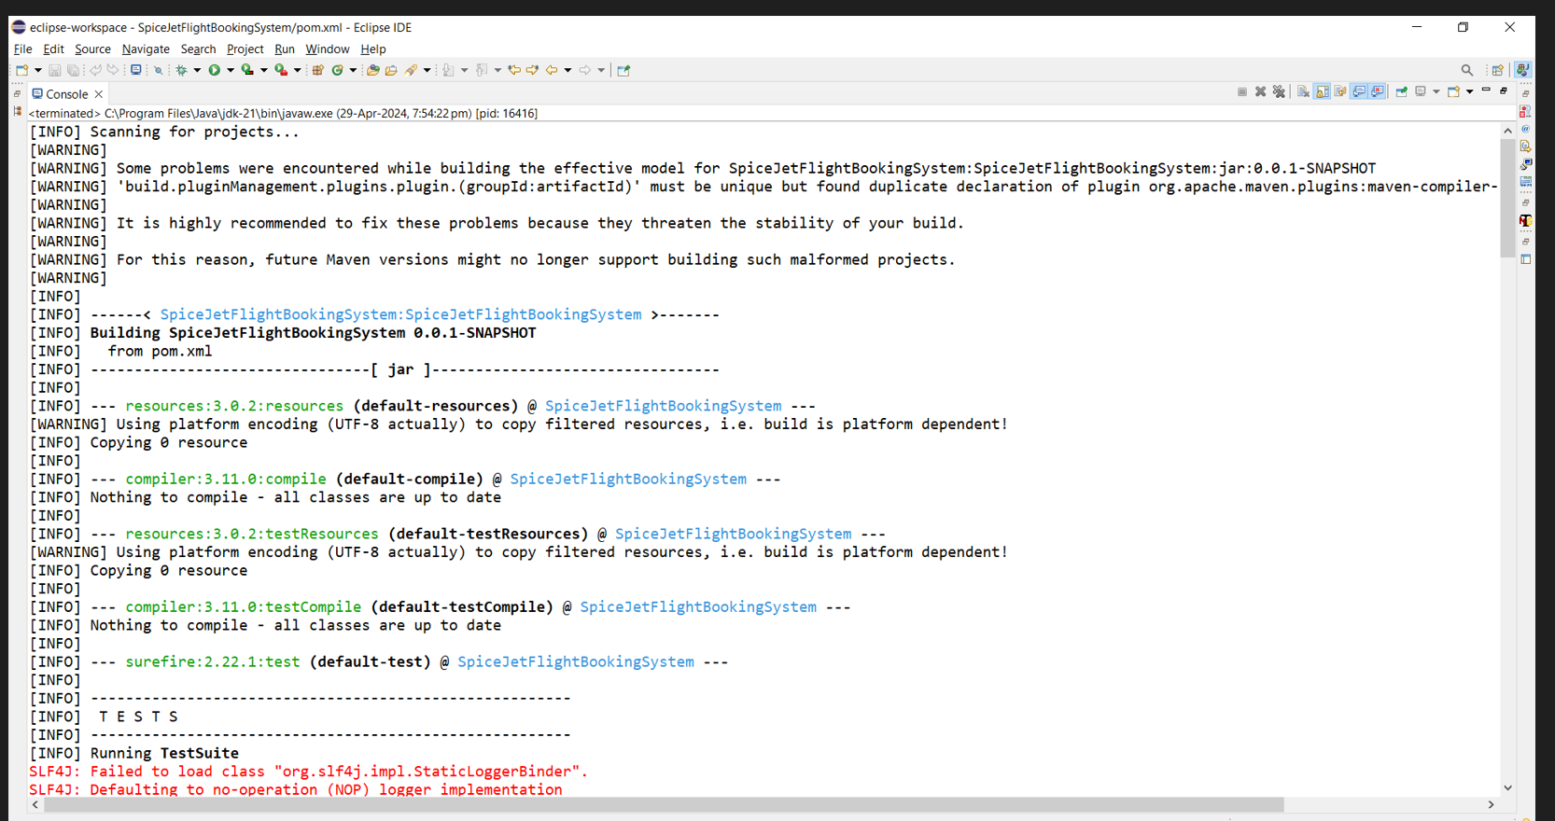

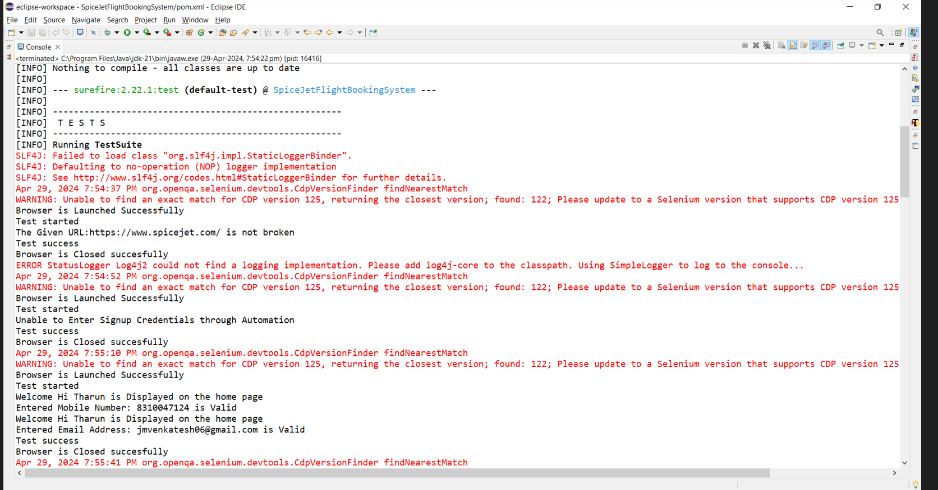

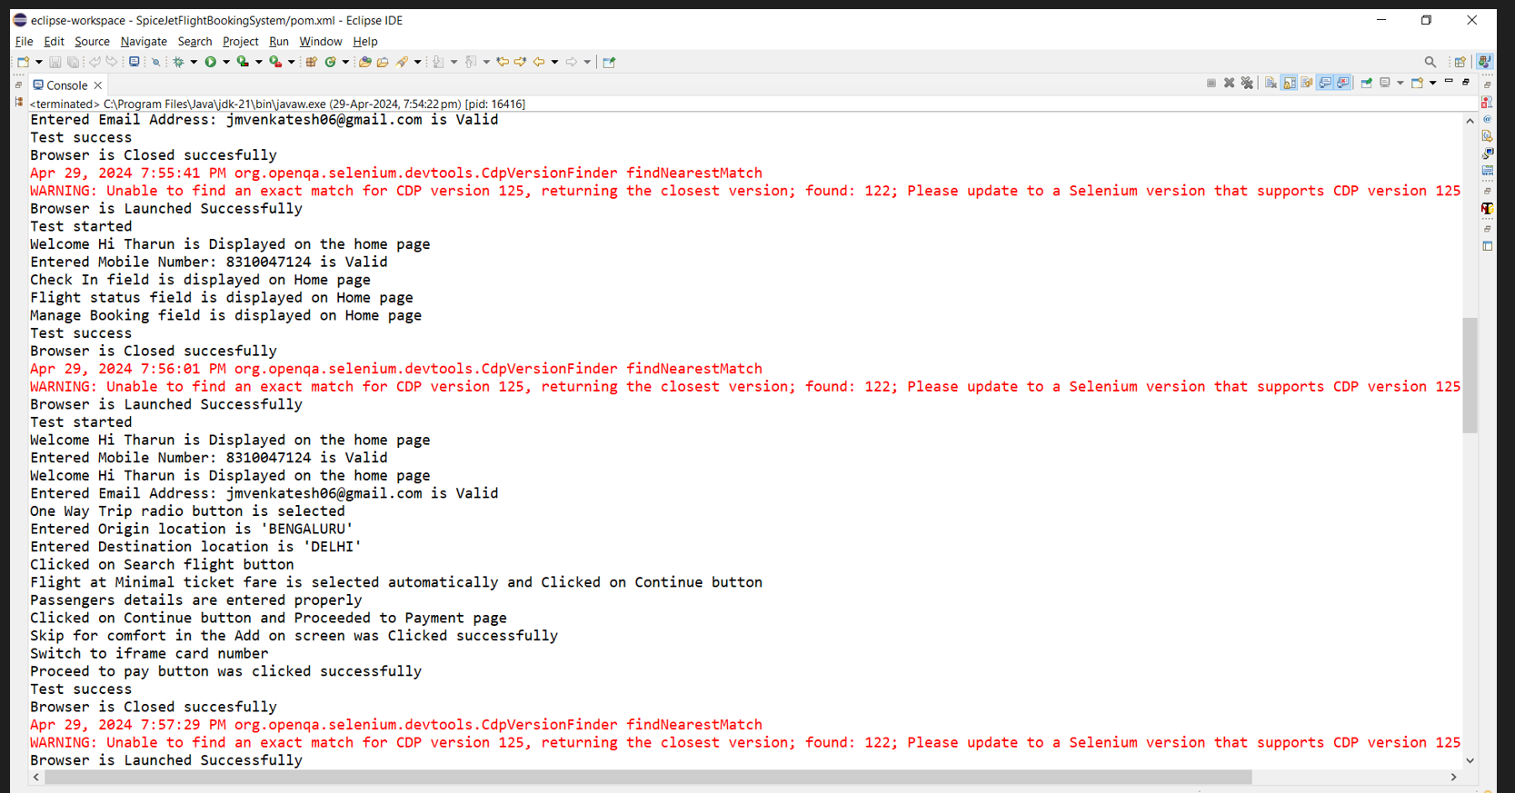

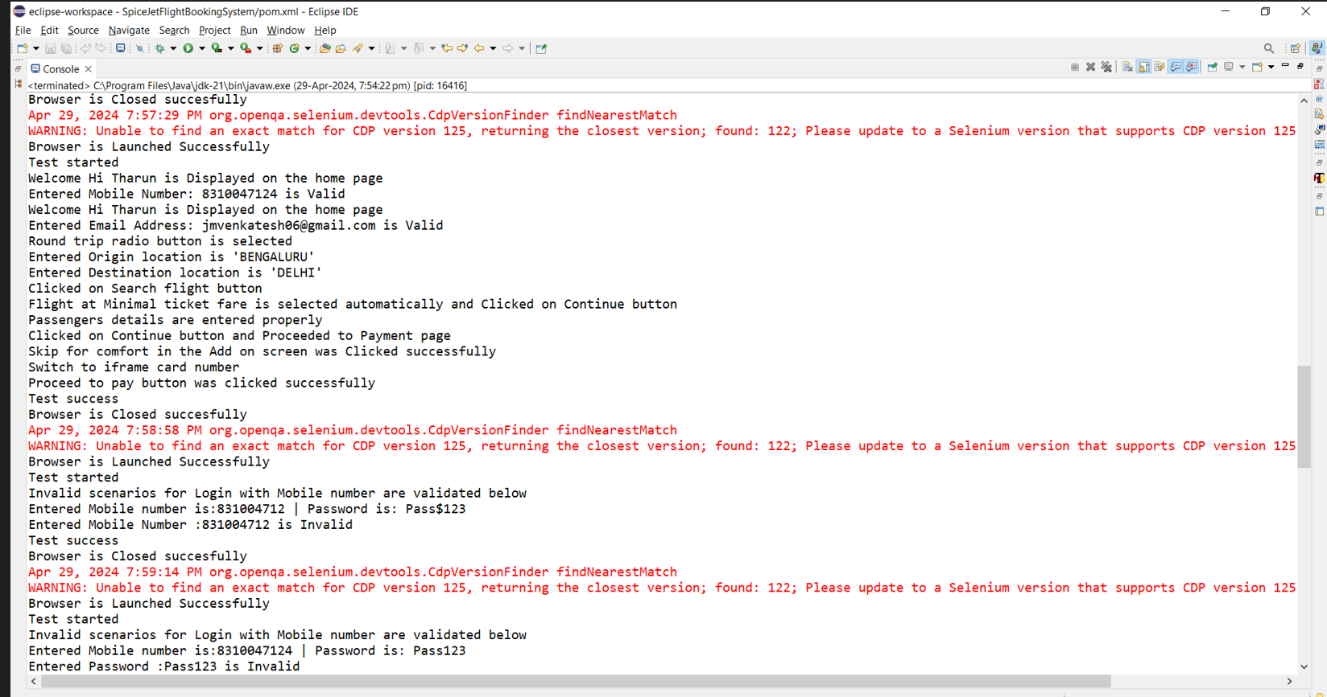

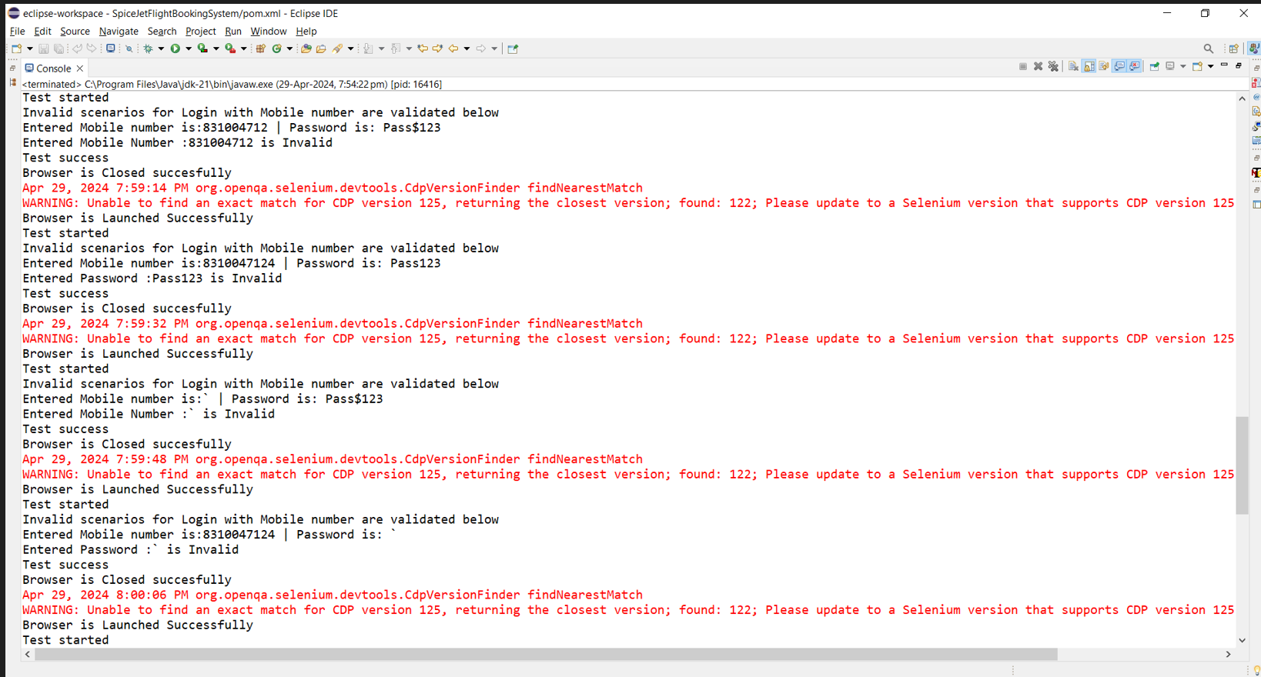

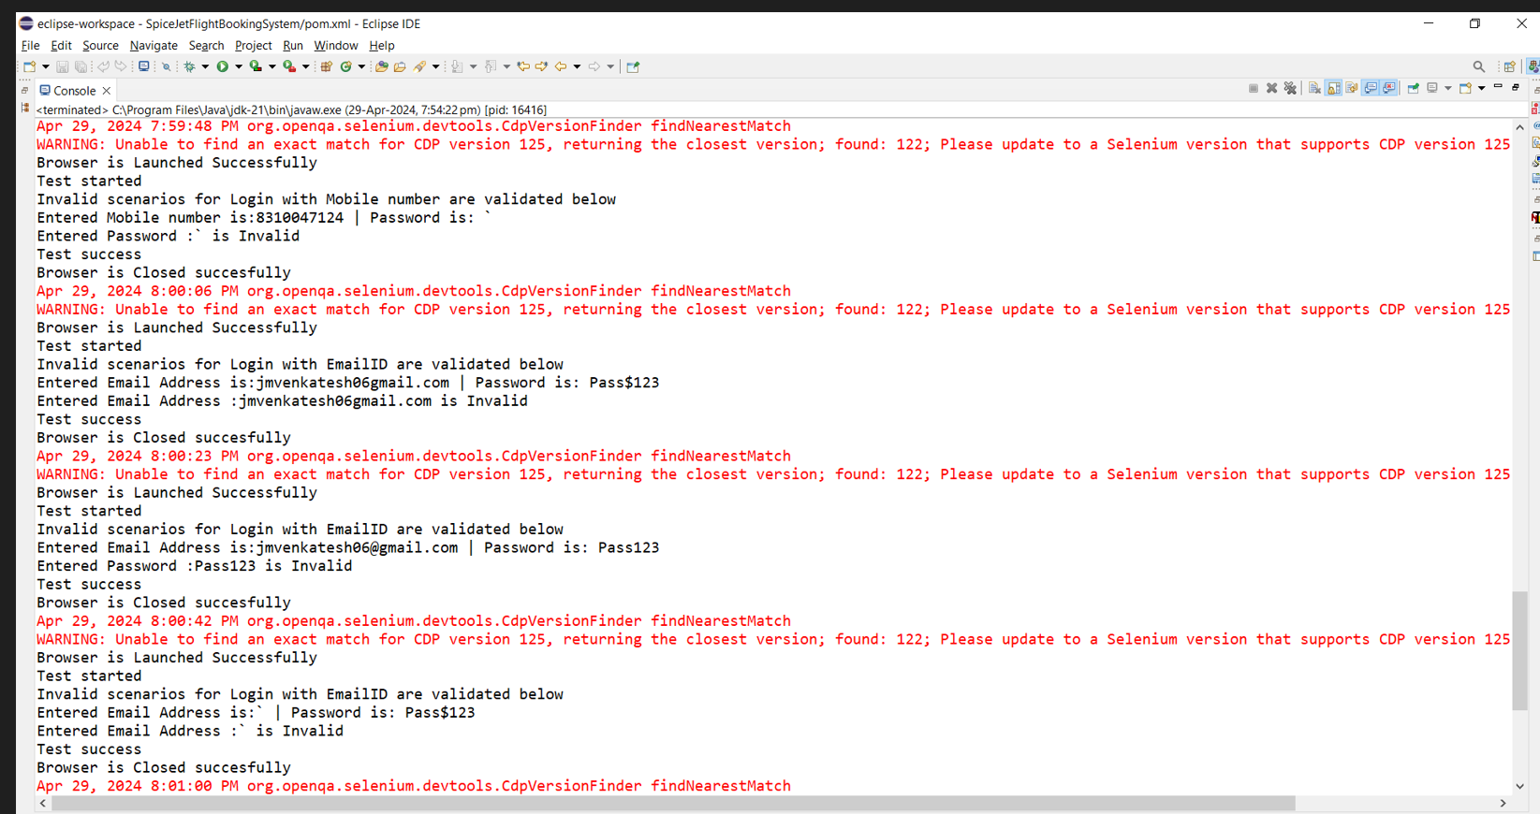

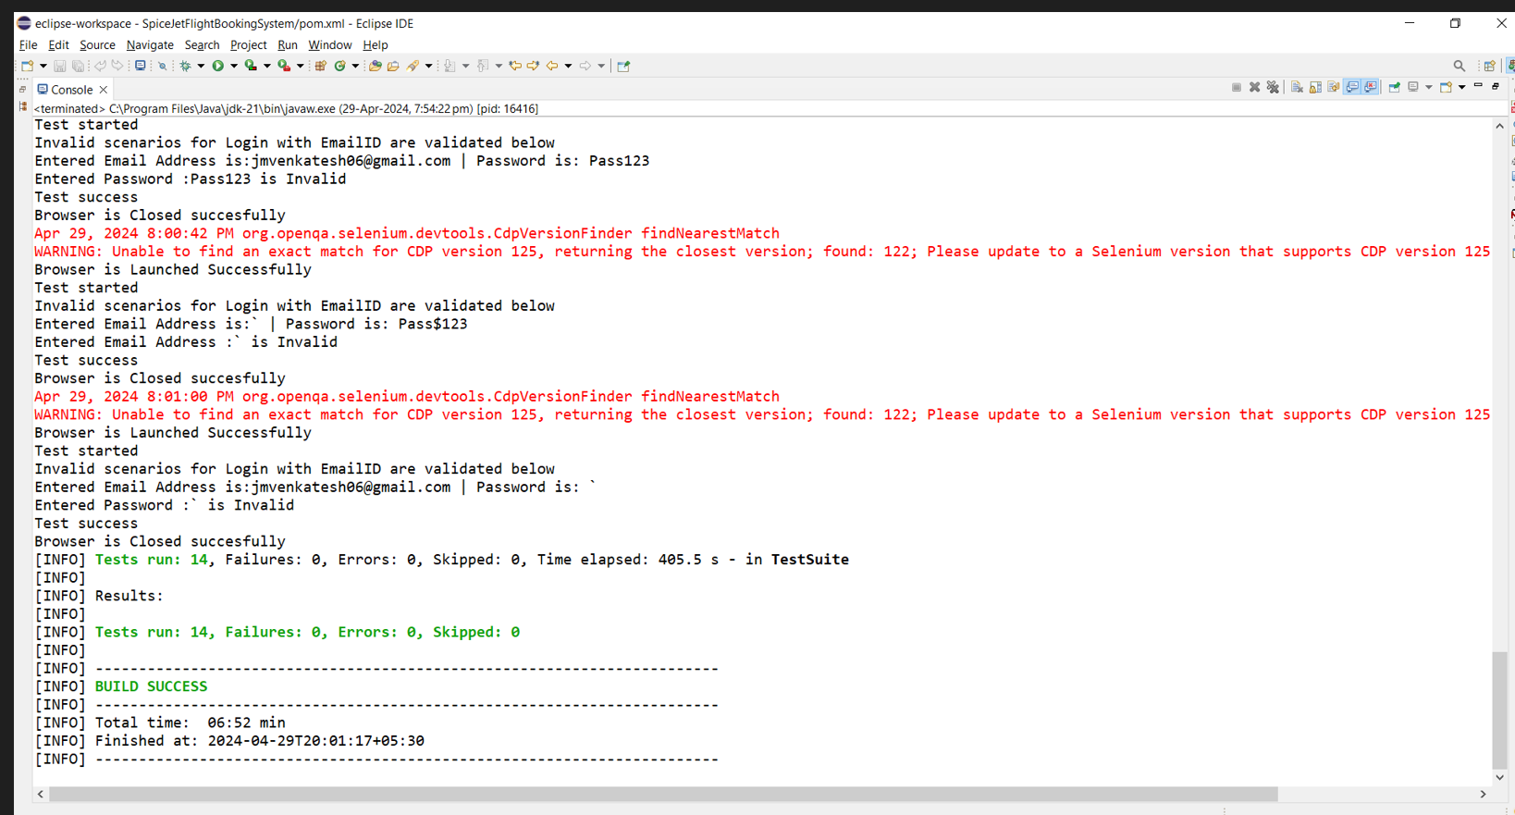

**Extentreport_output:**

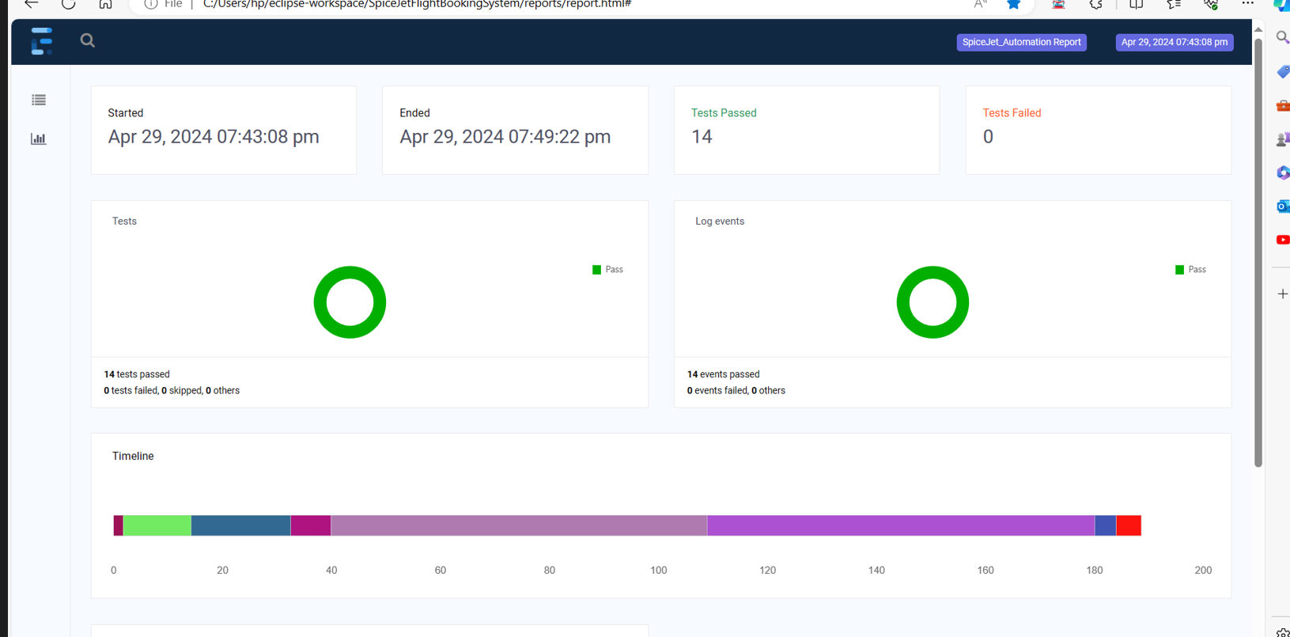

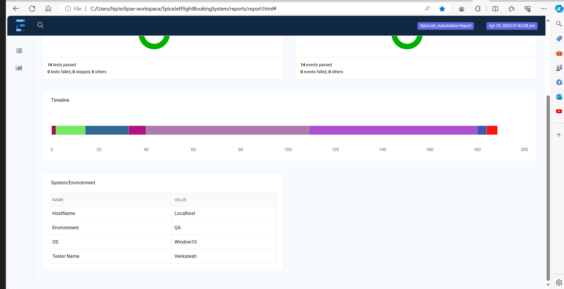

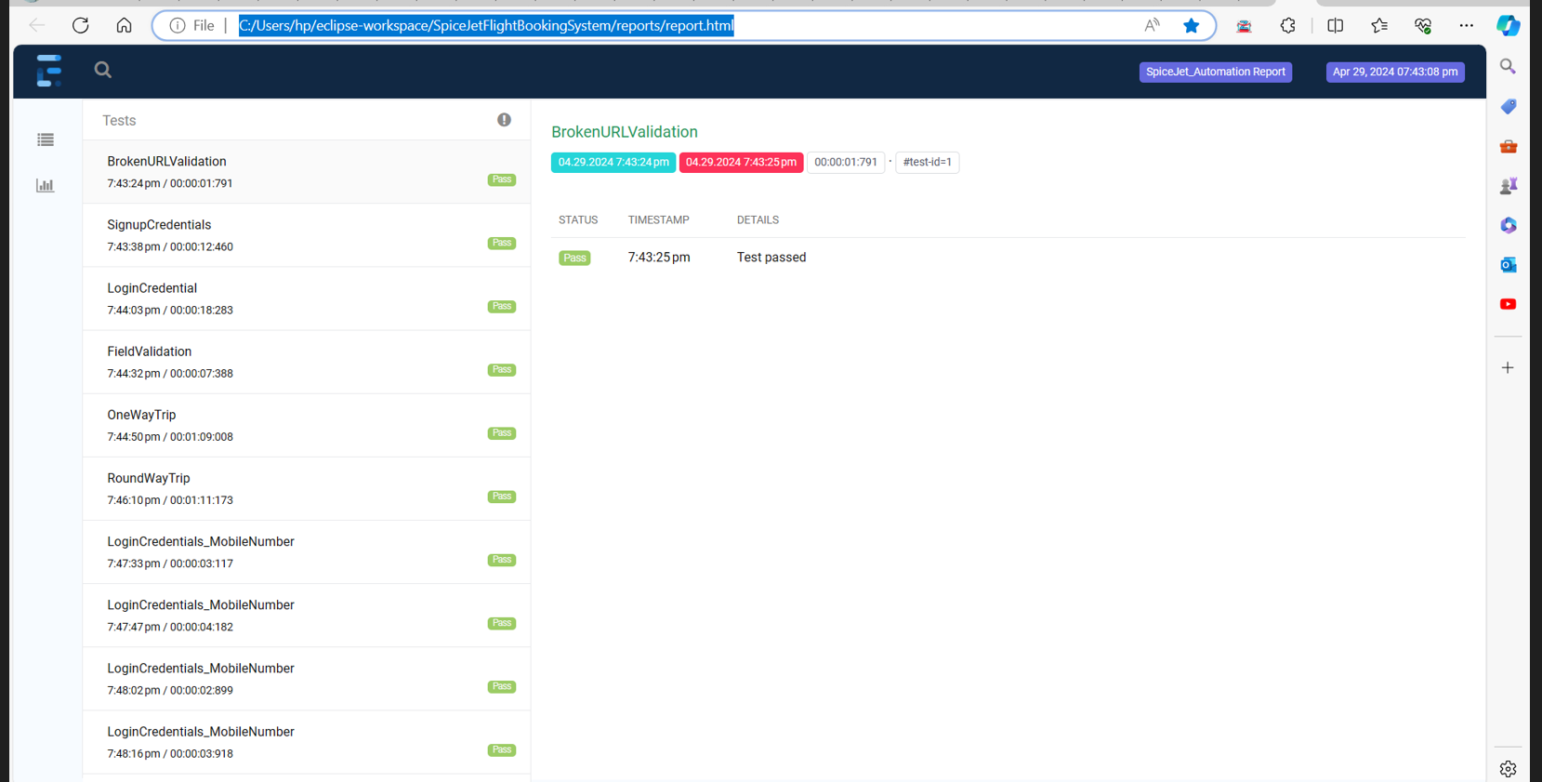

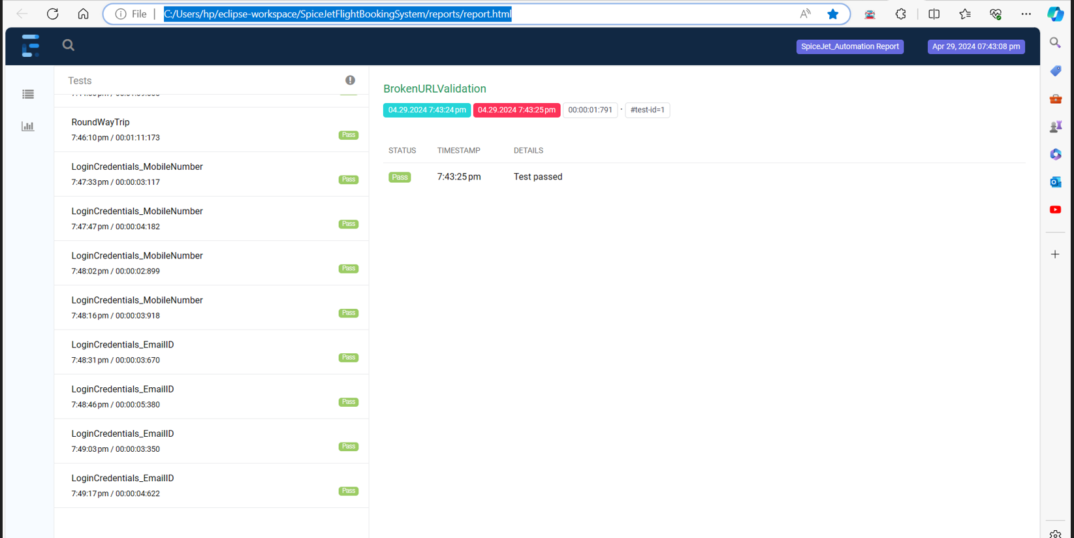

**Jenkins_Configurations:**

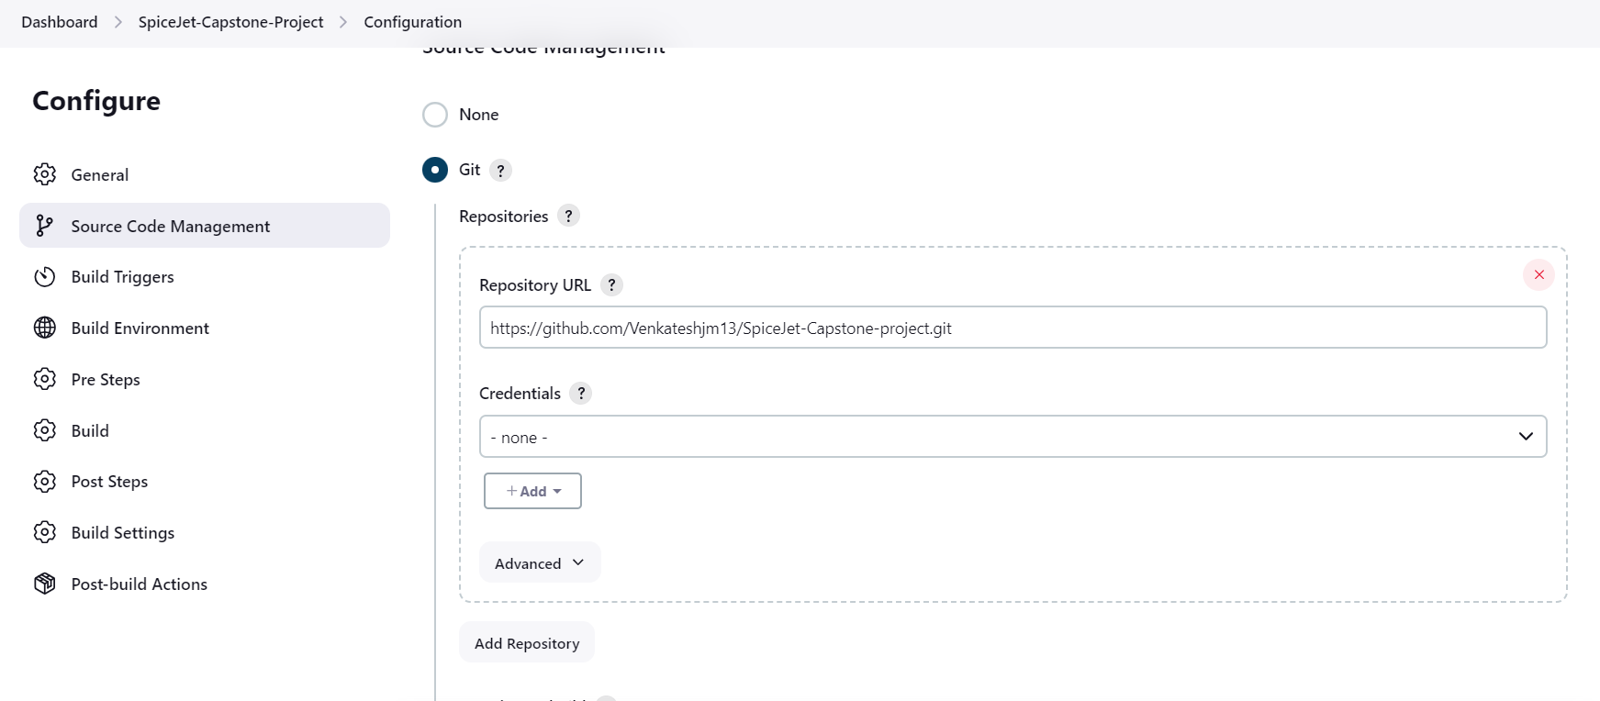

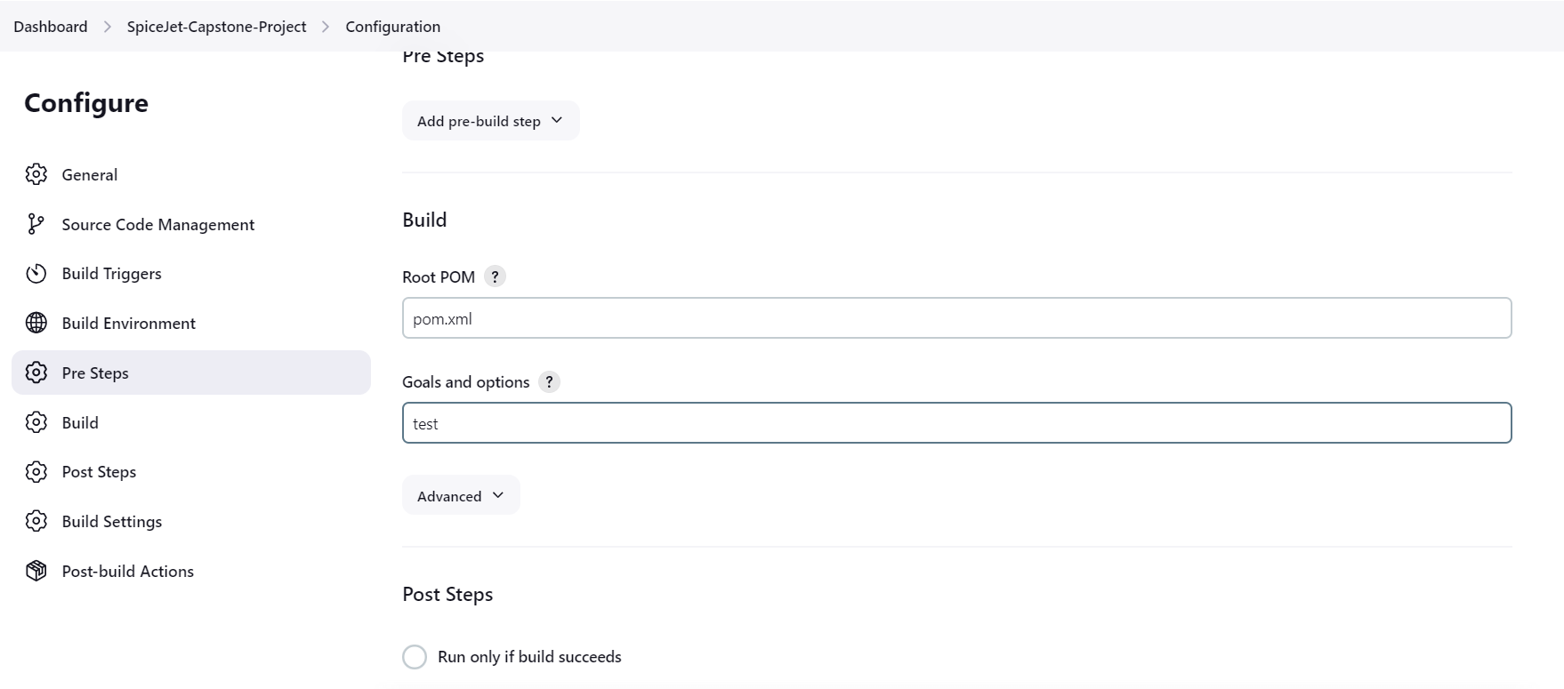

**Build trigger daily at 10:00 pm (test suite automatically triggers on daily basis )**

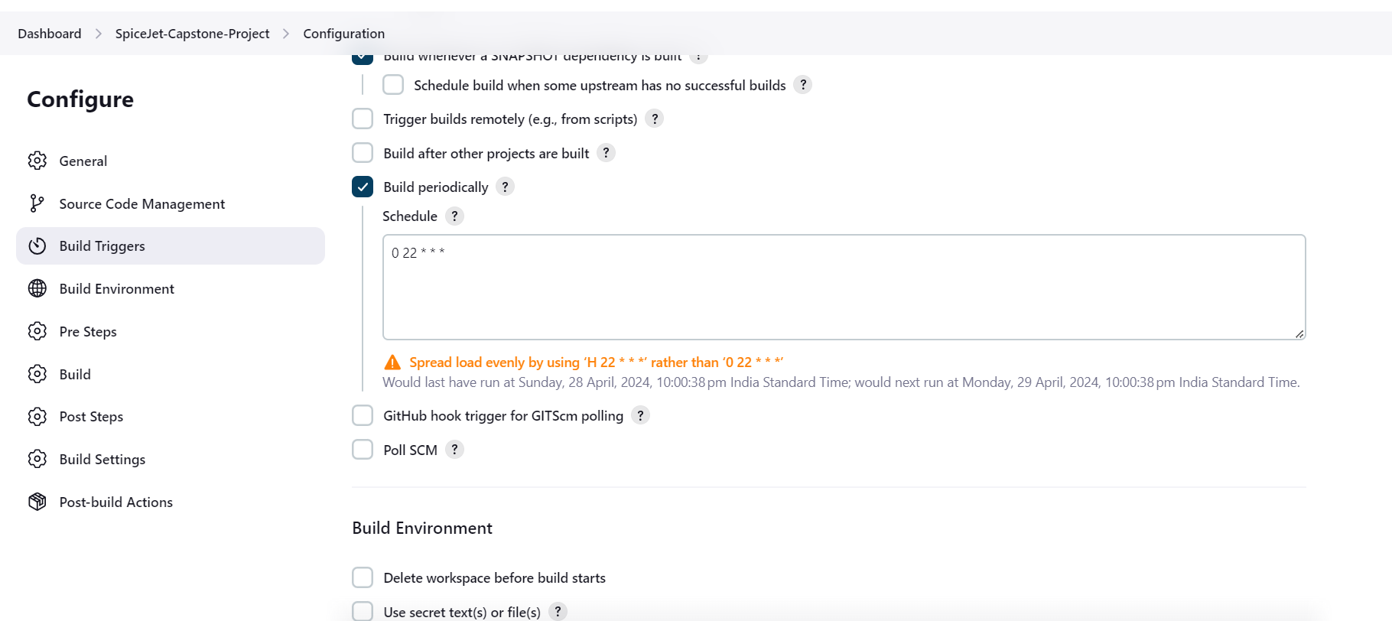

**Jenkins_output:**

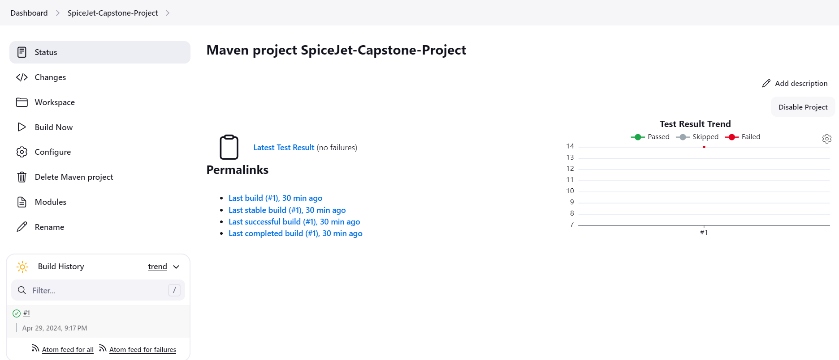

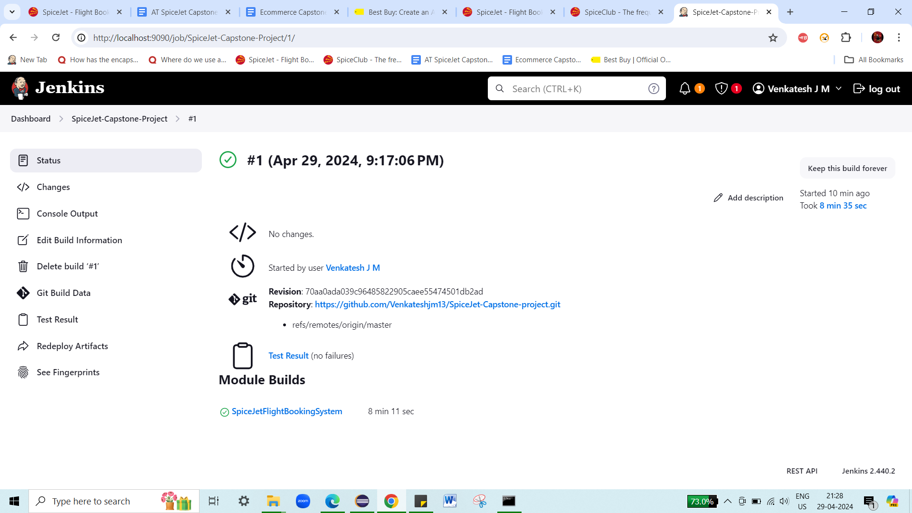

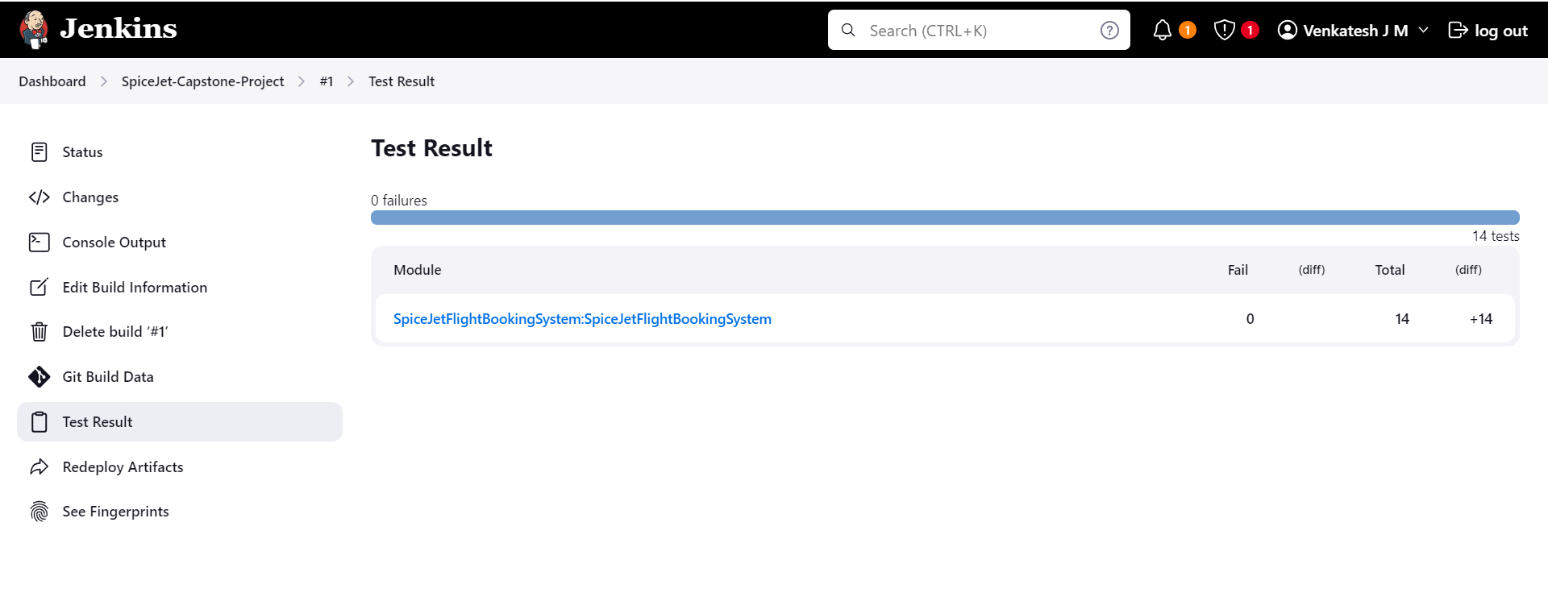

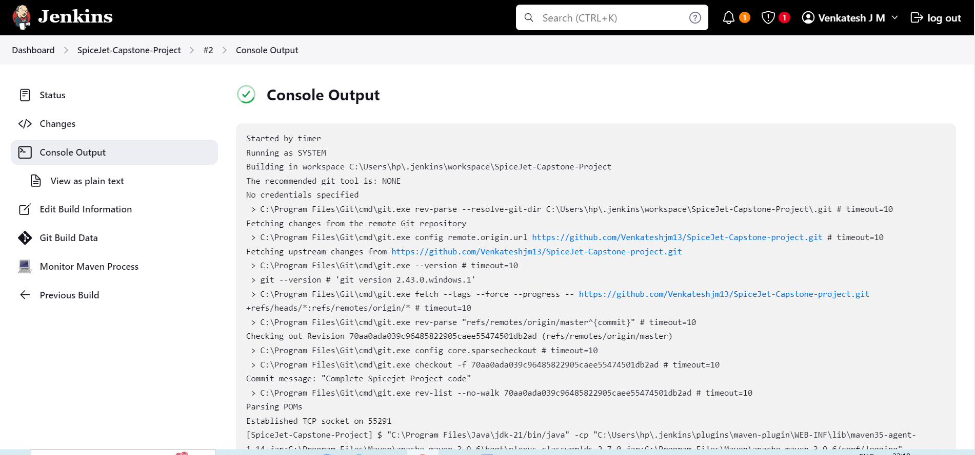

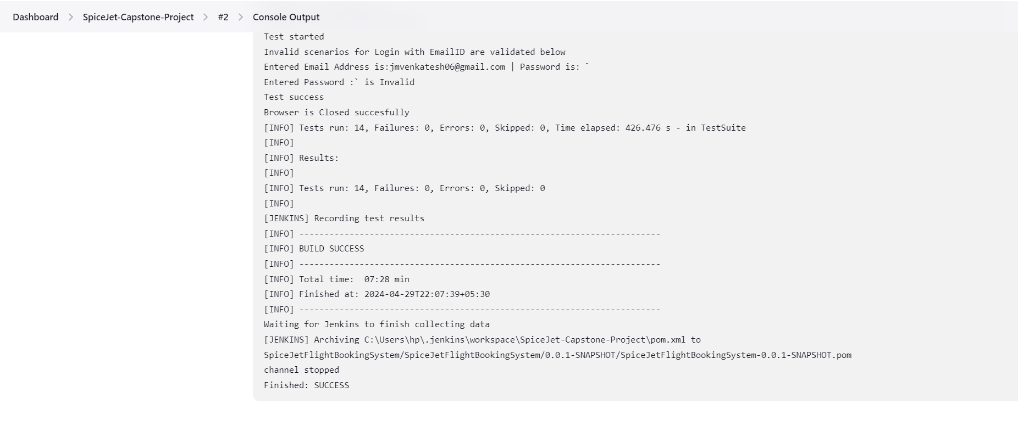

**Jenkins_JobScheduler_output:**

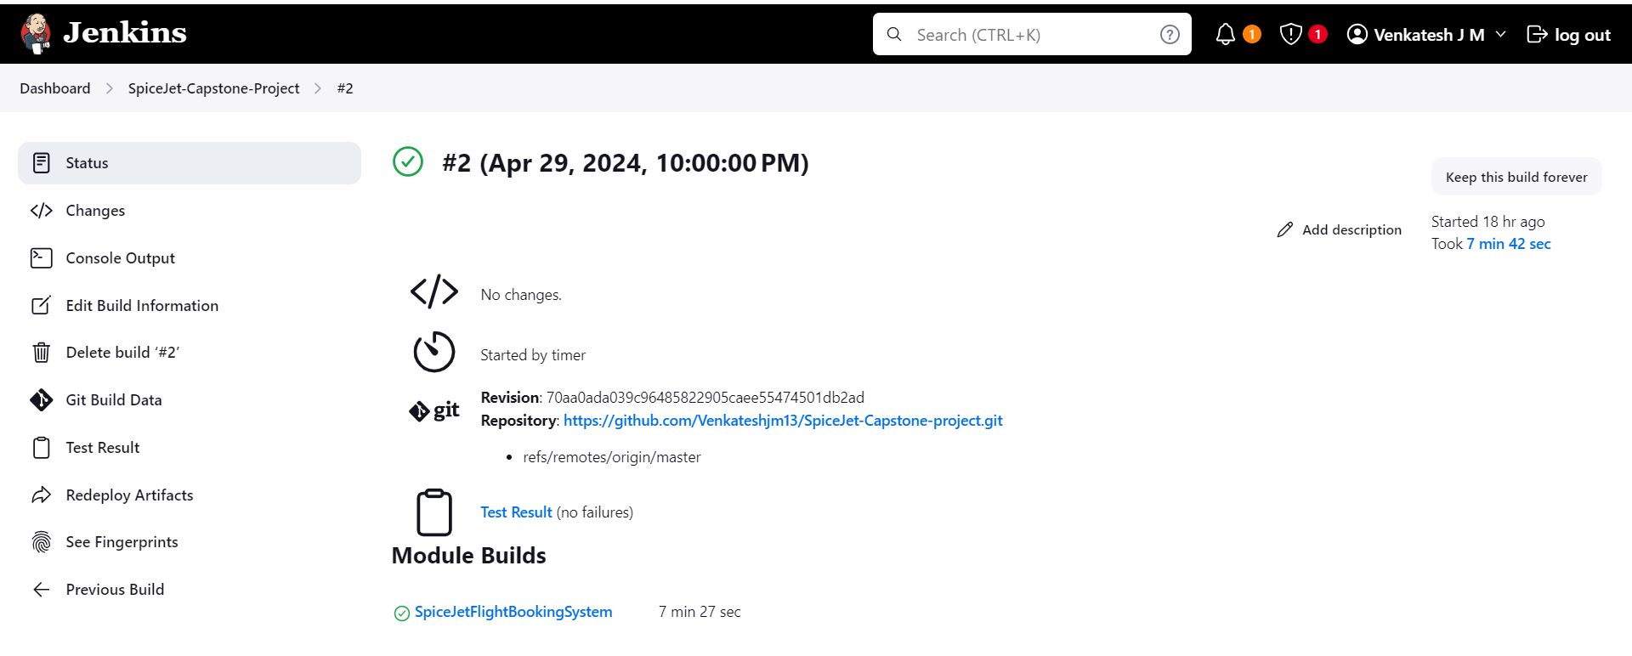

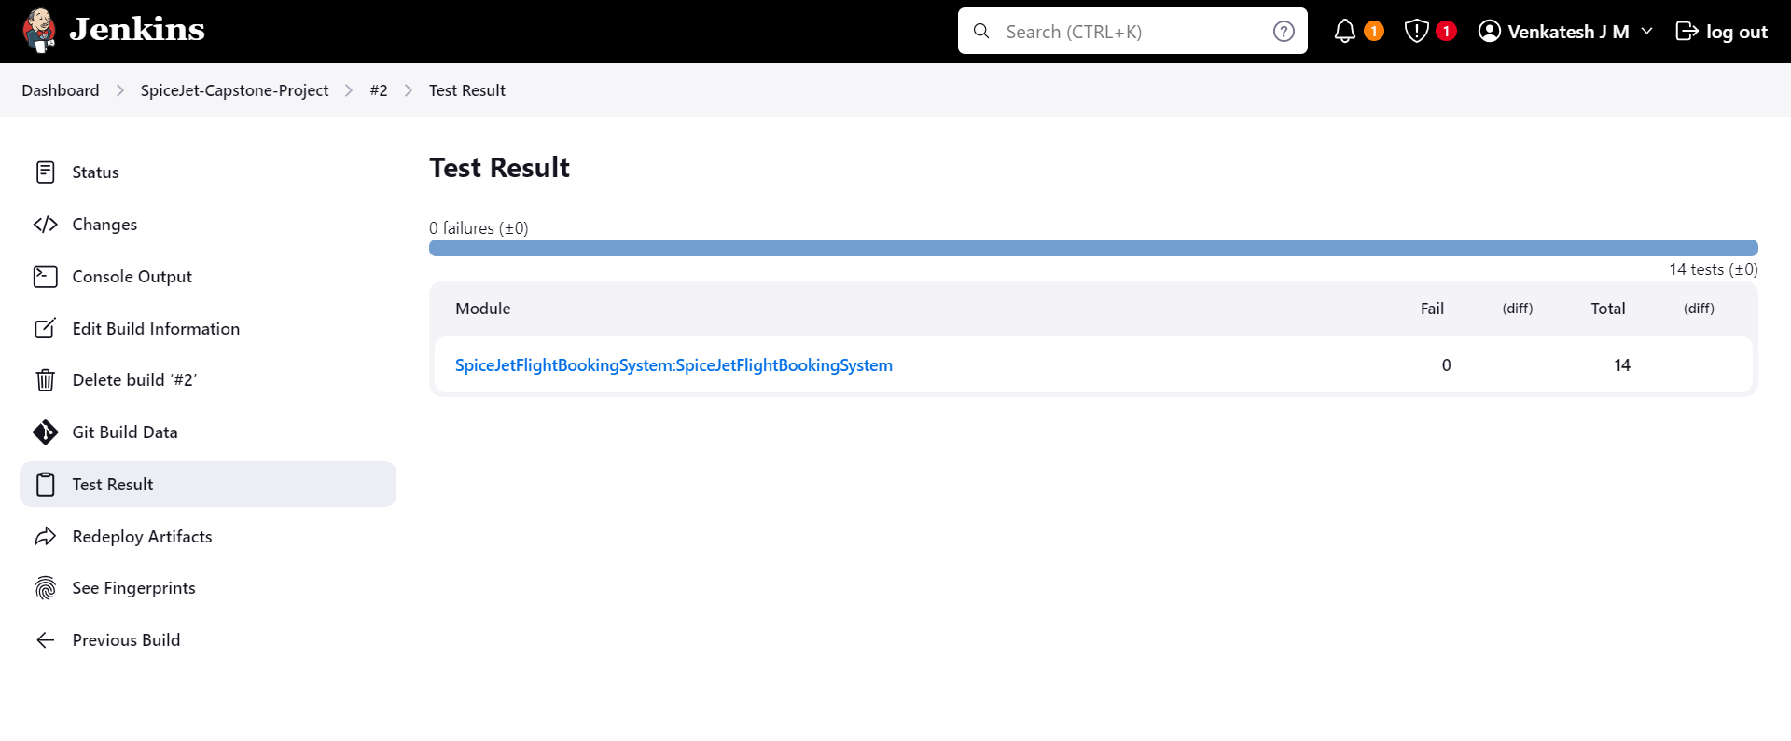

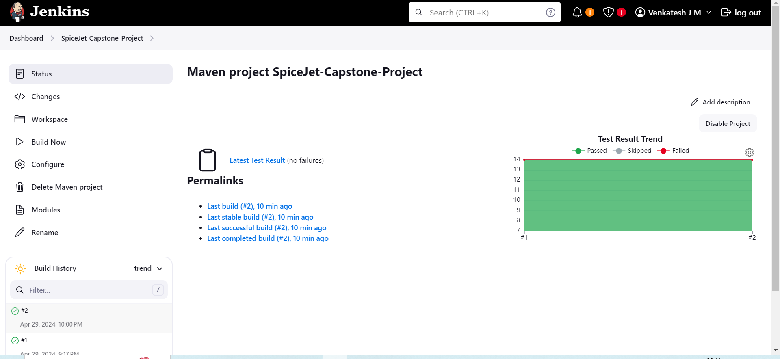

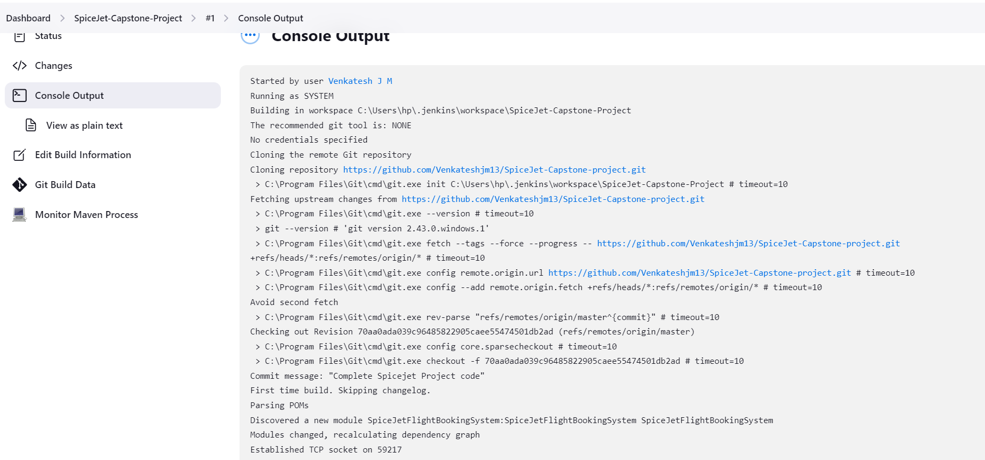

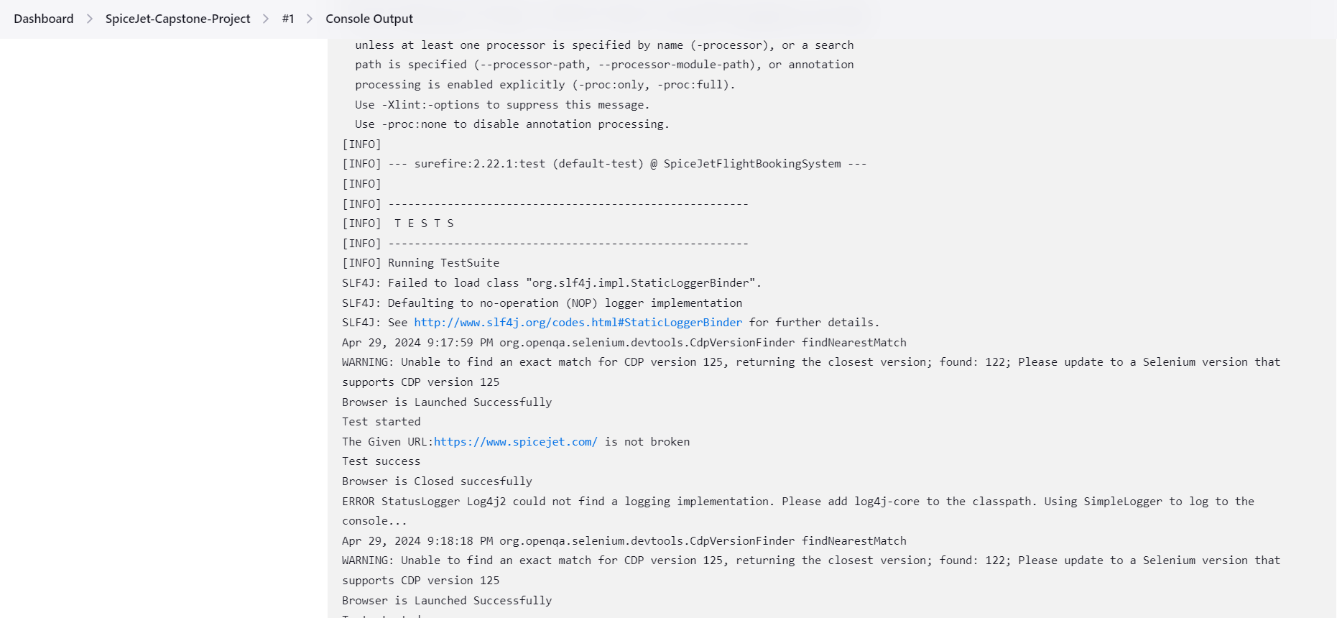

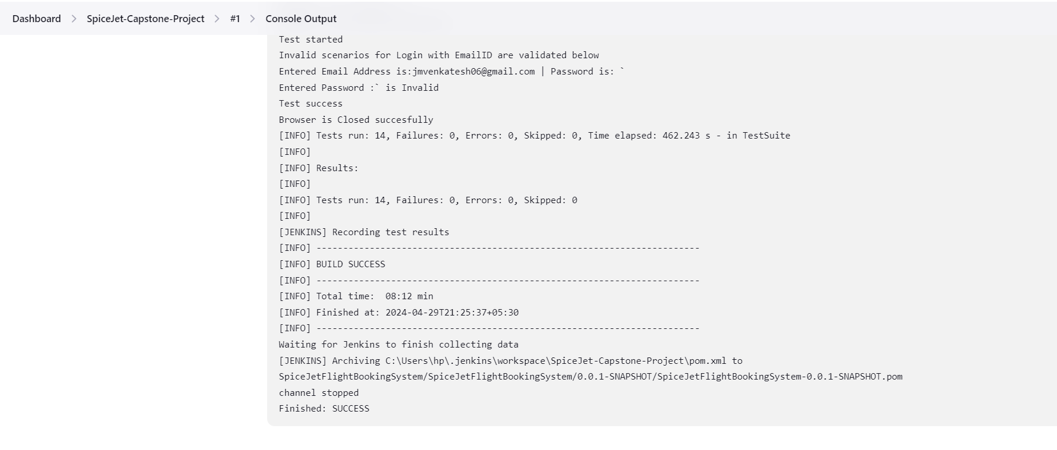

**Note: (Please refer the points )**

→For Signup not able to enter the data through automation

(Manually we are able to enter the data)

—>For Date picking through automation code not able to do it

(Used direct webelement of the particular date in the departure and return date)

→For Paymentpage ., not able to enter the card number through automation

(Sometimes it allows and sometimes it will not )

→I have used TestNG Framework with Data Driven testing for Signin and Signup automation test scripts

→If any error occurs in between the code ., try to rerun the code (the error occurred because of the website server will take time to load )

→For Failed test cases., it will take the screenshot automatically and save it in the SeleniumPOM_Screenshots folder inside the project directory

→For Cross Browser testing .,I have written code for Firefox, edge

→I have written code for Broken URL Validation and Headless browser

→Used Extent report to generate the reports based on the test case results (it shows whether the test case is Passed or Failed)

→The project also has Maven build for remote triggering of the build once per day using Jenkins